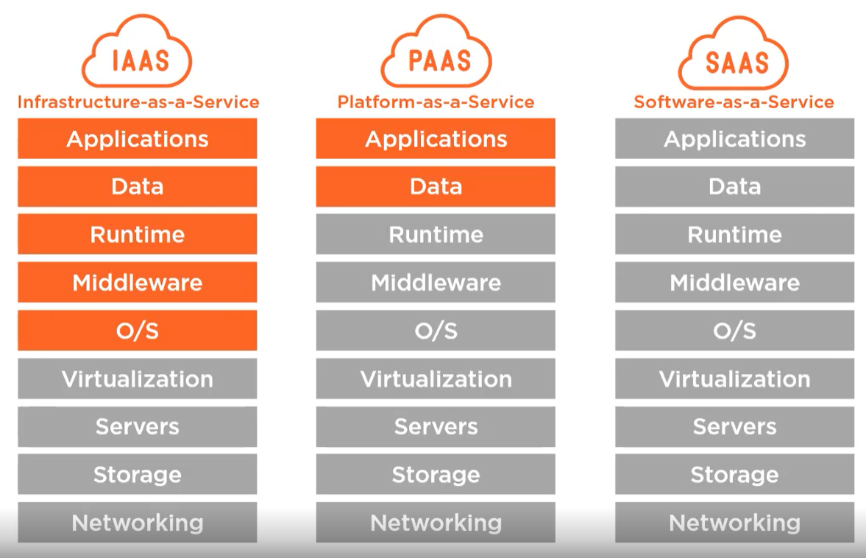

**CloudShell:** Other than AzureCLI and Powershell, there is an offering to launch a shell from the browser to manage Azure resources (Bash, Powershell, AzureCLI included).

* We don’t have to maintain the shell environment
* Requires an Azure file share to persist files

**mstsc**: shortcut command in ‘Run’ for remote desktop connection

After creating a resource group, its location cannot be changed.  
However, individual resources within that resource group may be in a different location than the group itself.

**Four tenants of cloud computing**

1. Resources are available on demand
2. Self service
3. Massive scalability
4. Billing based on consumption

Get commands for a module in PowerShell (see what’s available):

